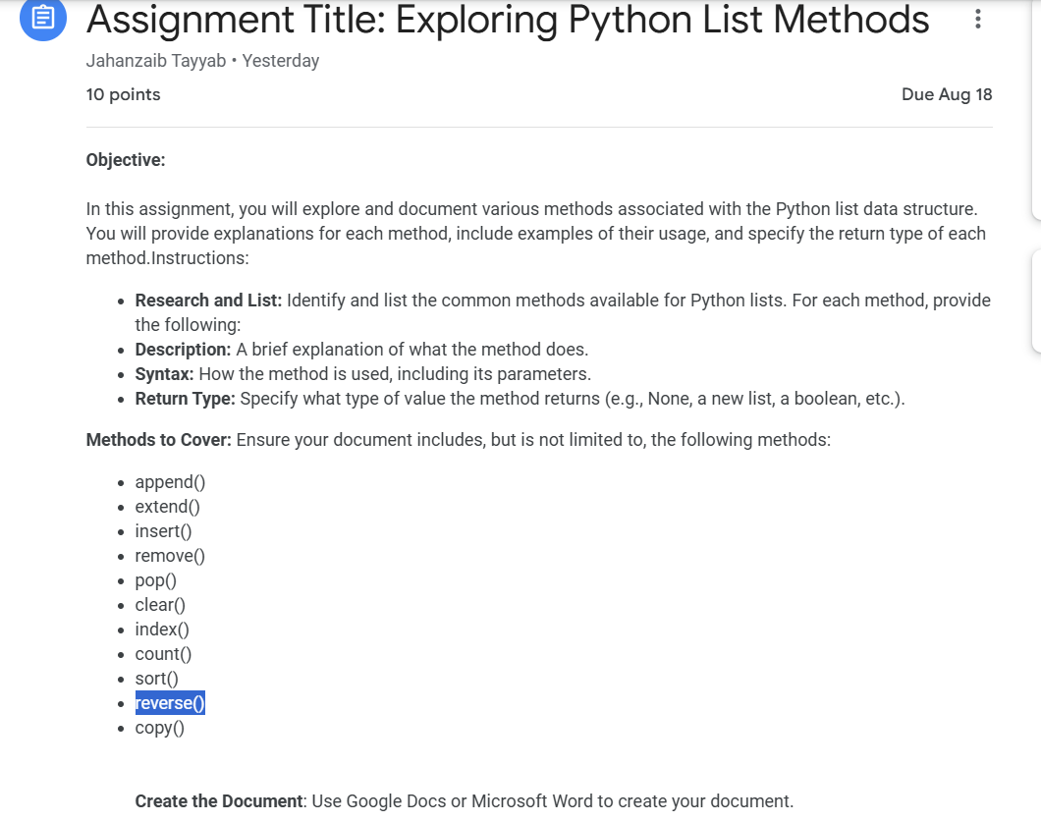

1. append()

**Description:** Adds a single element to the end of the list.

**Syntax:** list.append(element)

**Return Type:** None

1. extend()

**Description: Extends the list by appending elements from another list.**

**Syntax: list.extend(list)**

**Return Type: None**

1. insert()

Description: Adds a single element to the end of the list.

Syntax: list.append(element)

Return Type: None

1. remove()

**Description:** Removes the first occurrence of a specified element from the list.

**Syntax:** list.remove(element)

**Return Type:** None

1. pop()

**Description:** Removes and returns the element at a specified position in the list. If no index is specified, it removes and returns the last item.

**Syntax:** list.pop(index)

**Return Type:** The item removed from the list.

1. clear()

**Description:** Removes all elements from the list.

**Syntax:** list.remove()

**Return Type:** None

1. index()

**Description:** Returns the index of the first occurrence of a specified element.

**Syntax:** list.index(element, start, end)

**Return Type:** int

1. count()

**Description:** Returns the number of occurrences of a specified element in the list.

**Syntax:** list.count(element)

**Return Type:** int

1. sort()

**Description:** Sorts the elements of the list in ascending order. Can be customized with a key function and reverse flag.

**Syntax:** list.sort(key=none, reverse=false)

**Return Type:** None

1. reverse()

**Description:** Reverses the order of elements in the list.

**Syntax:** list.reverse()

**Return Type:** None

1. copy()

**Description:** Returns a copy of the list.

**Syntax:** list.copy()

**Return Type:** A new list that is copy of the original